Geology 3263
Structural Geology - Quiz 1 Takehome
Open books, open notes, open internet
Print out, fill out, bring to class
Due Wednesday, September 26th at the end of class

Name:____________________________________________

Answer All Questions. Mark up your quiz, then transfer your answers to the answer sheets. Turn in the answer sheet, keep the quiz.

A. Mixed Format

- A rounded grain of quartz that is greater than 0.0625 mm and less than 2mm would be
  - a mud particle.
  - a grain of sand.
  - a pebble.

- A bed of detrital sediment in which the coarsest grains are on the bottom and grain size decreases gradually toward the top of a layer is said to have
  - flaser bedding
  - graded bedding
  - inverted bedding
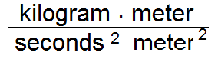
- What is one (1) i.e. 1 Newton/meter ² called?

  - 1 Joule
  - 1 Pascal
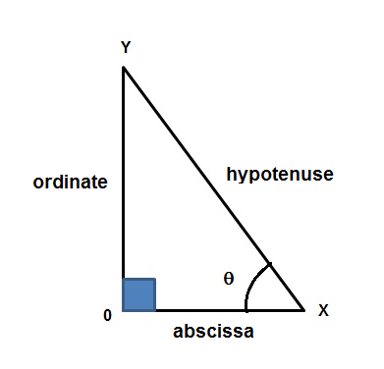
4. Notice this is a right triangle, because one of the angles (X0Y) is 90º
If θ = 35º and the hypotenuse is 2 meters
how long is the abscissa?
a. about 1.64 meters
b. about 0.41 meters

B. Match the terms

- Gabbro a. intermediate silica content

- Andesite b. coarse grain basaltic

- Rhyolite c. fine grain granitic

- Himalayas d. divergent margin
- NJ Triassic\Jurassic Rift Valley e. transform margin
- Andreas Fault f. convergent margin

C. Multiple Choice

- In divergent (MOR, rift) margins, the magmas that rise are typically
- silica poor (basaltic a.k.a. mafic)
- silica rich (granitic a.k.a. felsic)
- intermediate in silica content

- Above a subduction zone, e.g. in the Andes, the lavas that erupt on the surface are typically
- silica poor (basaltic a.k.a. mafic)
- silica rich (granitic a.k.a. felsic)
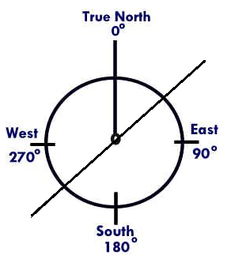
- intermediate in silica content (andesitic)

- On the right is a diagram of the points
of the compass. The diagonal line
represents a strike of about:
a. N42E
b. N 87 E

- Below is a cross-section from a geologic map. Rocks marked lP are Pennsylvanian, rocks marked P are Permian, rocks marked TR are Triassic,
J are Jurassic and K are Cretaceous.

Which came first?
a. Folding of Pennsylvanian through Cretaceous rocks.
b. The fault.

- The fault in the cross-section below is a(n)
a. Normal Fault
b. Reverse Fault
c. Transform Fault
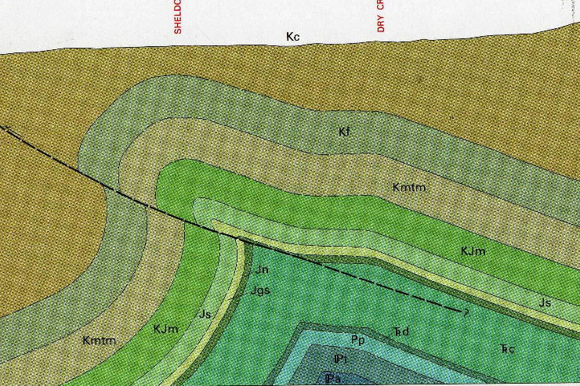

- Divergent margins typically have:
  - Reverse faults
  - Strike-slip faults
  - Normal faults.

- Continent-continent collisions typically have
- Folds and thrust faults
- Strike-slip faults
- Normal faults.
- Which is more likely to behave plastically?
- rock at low temperatures and pressures
- rock at high temperatures and pressures

- Which is more likely to behave elastically?
- rock at low temperatures and pressures
- rock at high temperatures and pressure
- Stress is the term used for
- Pressure on a gas
- Pressure on a solid
- Pressure on a liquid

- Stress is
- Force/Area
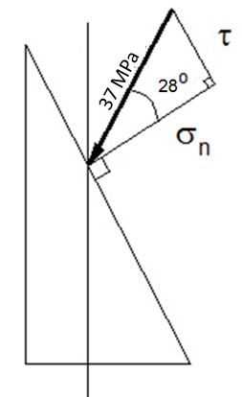
- Force x distance
- 1/2 mass x Velocity²

- A stress of 37 MPa pushes on the inclined plane shown.
Calculate the normal stress σ_{n} and the shear stress τ
in MPa.
a. σ_{n} is ~32.7 and τ is ∼ 17.4 MPa
b. σ_{n} is ~83.4 and τ is ∼ 41.8 MPa

23. This air photo shows folded rocks exposed at the surface.The oldest rocks are in the center, and the layers all dip away from the center. The nose points north. This is
a. a syncline plunging north
b. an anticline plunging north
c. an anticline plunging south
d. a syncline plunging south

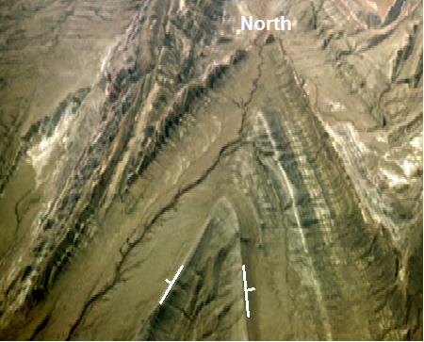

Geology 3263
Structural Geology - Quiz 1 Takehome
Open books, open notes, open internet
Due Wednesday, September 26th at the end of class

ANSWER SHEET

Name: __________________________

Circle your answer:

1. a or b

2. a or b

3. a or b or c

4. a or b or c

5. a or b or c or d or e or f

6. a or b or c or d or e or f

7. a or b or c or d or e or f

8. a or b or c or d or e or f

9. a or b or c or d or e or f

10. a or b or c or d or e or f

11. a or b or c

12. a or b or c

13. a or b

14. a or b

15. a or b or c

16. a or b or c

17. a or b or c

18. a or b or c

19. a or b

20. a or b or c

21. a or b or c

22. a or b

23. a or b or c or d

